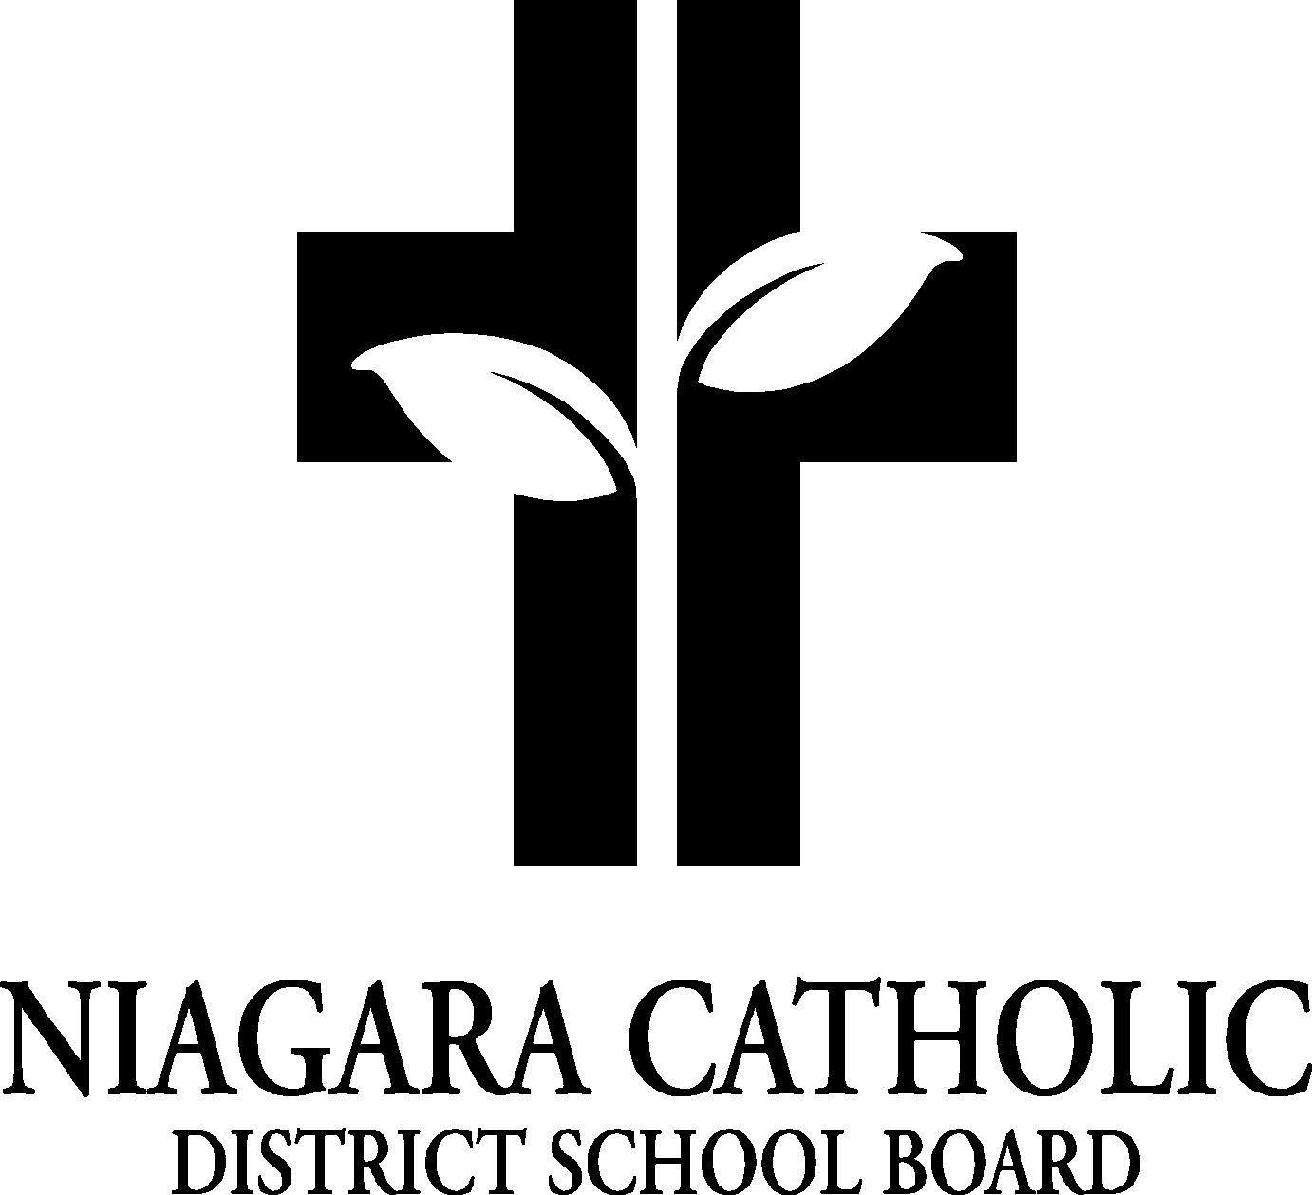

MINUTES OF THE
St. John Henry Newman CATHOLIC SCHOOL COUNCIL MEETING

Tuesday November 17, 2020
Virtual

Minutes of the Meeting of the St. John Henry Newman Catholic School Council, held on Tuesday November 17, 2020 at 6:00 p.m.

The meeting was called to order at 6:30 p.m. by Principal and Chair Mr. Sirianni and Silia Stapleton
A. ROUTINE MATTERS

1. Opening Prayer

The opening prayer was led by Julie Mangiacasale

2. Roll Call

CATHOLIC SCHOOL COUNCIL MEMBERSHIP |  | Present | Excused | Absent
Principal/Vice-Principal  Secretary/Treasurer | Paolo Sirianni (Acting Principal)  Julie Mangiacasale (Vice-Principal & Secretary)  Maria Elia (Treasurer) | 
Chair | Jessica Petrella  Silia Stapleton
Co-Chair(s) | Jessica Petrella  Silia Stapleton
Teacher Representative | Marre Gray
Non-Teaching Representative
Student Representative
Parish Representative | Jose Evangelista  Kelly Fiala  Marie Kowalczyk
Community Representative | Marie Kowalczyk  Rochelle Horwath  Lyndsay Shura
OAPCE Representative | Marilyn Fabiano
PARENT/GUARDIAN MEMBERS
Jessica Petrella
Silia Stapleton
Phyllis Deprophetis
Sonia Taddeo
Lindsay Shura
Maria Elia
Kelly Brown-Fiala
Katie Bender
Barbara Perone

Jose Evangelist
Marilyn Fabiano
Rochelle Howarth
Ann-Marie Abbruscato
Ludmilla Morretto
Luisa Carbonara
Marre Gray
Marie Kowalezyk

3. Approval of the Agenda

Moved by Lindsay Shura
Seconded by Silia Stapleton
THAT the St. John Henry Newman Catholic School Council approve the Agenda of the St. John Henry Newman Catholic School Council Meeting of Tuesday November 17, 2020
CARRIED

4. Disclosure of Conflict Interest

No disclosures of conflict of interest were declared with any items on the agenda.

5. Approval of Minutes of the St. John Henry Newman Catholic School Council Meeting of Tuesday November 17, 2020

Moved by Lindsay Shura
Seconded by Silia Stapleton
THAT St. John Henry Newman Catholic School Council approve the Minutes of the St. John Henry Newman Catholic School Council Meeting of September 29, 2020 as presented.
CARRIED

- PRESENTATIONS

- POLICIES FOR VETTING-FEEDBACK
..\..\Policy Vetting\100.5 - Establishment and Cyclical Review of Policies Policy.pdf
Please provide feedback to Mr. Sirianni or Mrs. Mangiacasale or directly to Jennifer Pellegrini
Please provide your name if sending feedback
- PRINCIPAL’S REPORT

- Niagara Catholic Parent Involvement Committee (NCPIC) Report
- At the Niagara Catholic Parent Involvement Committee meeting of November 5, 2020, Superintendent Forsyth-Sells welcomed new and returning members. Fr. Paul MacNeil, Bishop/Diocesan representative presided over the commissioning ceremony of the members of the Niagara Catholic Parent Involvement Committee, as they publicly proclaimed their commitment to promote the Mission of Catholic education and the Mission, Vision and Values of the Niagara Catholic District School Board.
- Carrie Vernelli was elected as the Chair of the Niagara Catholic Parent Involvement Committee to hold a term of office from November 5, 2020 to September 2021. Chris Kouroushis will continue as the Co-Chair for the 2020-2021 school year. The revised NCPIC By-Laws as approved by the NCPIC will be presented at the December 15, 2020 Board meeting.
- The SEAC members have been working to update the SEAC Brochure and the Student Support Brochure to reflect updates to the publications. Upon final approval, the updated publications will be made available to families and to school staff.
For the time being, the SEAC members have been meeting monthly in a virtual format. Please contact Jennifer Lanese, Administrative Assistant to Gino Pizzoferrato at Jennifer.lanese@ncdsb.com or 905-735-0240 x 222 to participate in the virtual meeting as an observer.

- Special Education Advisory Committee (SEAC)
Report ..\Parent Involvement\Parent Involvement Memo 051 (2020-2021) Attachment 2-2020-2021 SEAC Membership.pdf
Report ..\Parent Involvement\Parent Involvement Memo 051 (2020-2021) Attachment 2-2020-2021 SEAC Membership.pdf
- Catholic School Council Financial Statement: Current Balance: $7041.61 (pizza money still to be taken out of the account)
- Co-Chair Report: Pizza Day was good for the first hot food day.
-Will refine delivery time
-Will refine process for marking pizza slices (cheese/pepperoni)
-Consider having a maximum order of 4 slices offered on cash online
-Looking into future-have indoor lunch recess for hot lunch days
-All cardboard boxes for pizza were recycled…each class was provided with extra recycle bags

- Future Food Days: Looking into a possible pasta day and possibly adding chips in the future
- Spirit Wear Feedback: Good turn out
-parents posting what their kids were doing and they were participating
-Grade 8’s suggested having an 80’s day in the future
-Christmas Spirit Week suggested for December
10. Christmas Shop: On Pause this year
-Possible alternatives TBD
11. Clothing/Shoe Drive: Looking at having a used clothes and shoe drive in January
-Please start to save any donations
12. Parking Lot: Stagger pick-ups
-JK/SK & older siblings depart at 2:55 p.m.
-3:15 p.m. suggested time to pick-up to help avoid congestion and buses
13. Faith Formation: Father Paul blessed our school at the official school name change to St. John
Henry Newman on November 10, 2020
-Director Cirprano, Chair Fera, Co-Chair Sicoli and Superintendent Pizzoferrato were also in
Attendance
-We now have a live link to Our Lady of the Scapular church for mass on Monday’s at
12:30 p.m.
-We will continue to use our front foyer as our school chapel
-We will host our school liturgies in the foyer
-Confirmation-will be sometime in February, date(s) TBD
-Holy Communion-Gr. 3’s received their First Holy Communion this past Sunday
-Father Paul came to the school to congratulate the Grade 3 students and say hello to their
Classes
-Christmas Mass dates and times will be added to the Newman News
-Reminder that the church capacity is reduced to 30%
-Food Drive will take place in December and help support Niagara Soup Kitchen
14. Student Senators: Isabella Minovski and Kylie Stevens
-Isabella Minovski was elected as our Family of School Senator
-Kate Bishop was elected as our Family of School Community Representative
15. Valentine’s Day Raffle: Idea for February (in place of the Triathlon)
16. Niagara Nutrition Partners: Grab-n-go snacks will be provided for each class with tongs for
The teachers to hand out snacks to their students
17. Lockers have been introduced to students as the weather is changing and routines have been put
Place by classroom teachers
18. Indoor shoes have been requested for families to send into school with their children
19. ECO schools: Mr. Van Wissen is heading up a Garden Clean with students before winter
20. St. Paul Christmas Road Show: We will be sending a video of some student performances
(Following Covid requirements) to St. Paul to add to their virtual Roadshow
21. Milk Orders: Will revisit in the New Year
22. Fundraiser Ideas: Discussions continue to determine fundraising ideas

- OAPCE REPORTS
No report

- STAFF REPORTS

- AGENDA ITEMS-DISCUSSION FOR FUTURE MEETINGS

- NEXT MEETING
January 12, 2021

- CLOSING PRAYER was led by Mr. Sirianni

- ADJOURNMENT
Moved by Mr.Sirianni
Seconded by Ms. Gray
THAT the Tuesday November 17, 2020 meeting of the St. John Henry Newman Catholic School Council be adjourned.
CARRIED

This meeting was adjourned at 7:30 p.m.

